CQL SCREENSHOTS

* **Key space creation:** key space is created with the following command



* **Table creation**: A employeess table is created with the command shown In the following screenshot

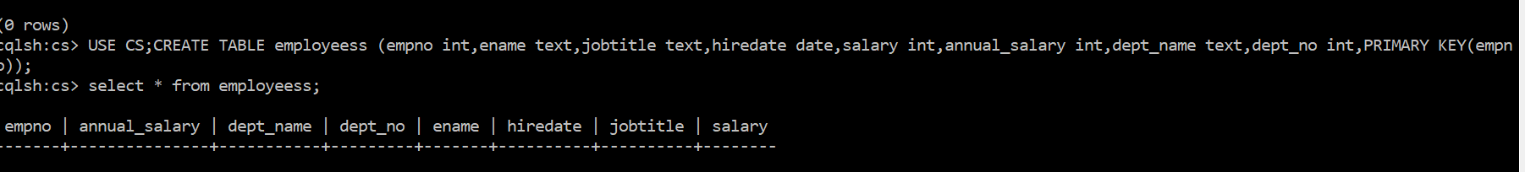

**1.List the empno,ename,jobtitle,and hiredate of employee from the employee table.**

**Employee table data insertion:** Data is inserted into the table using the insert command

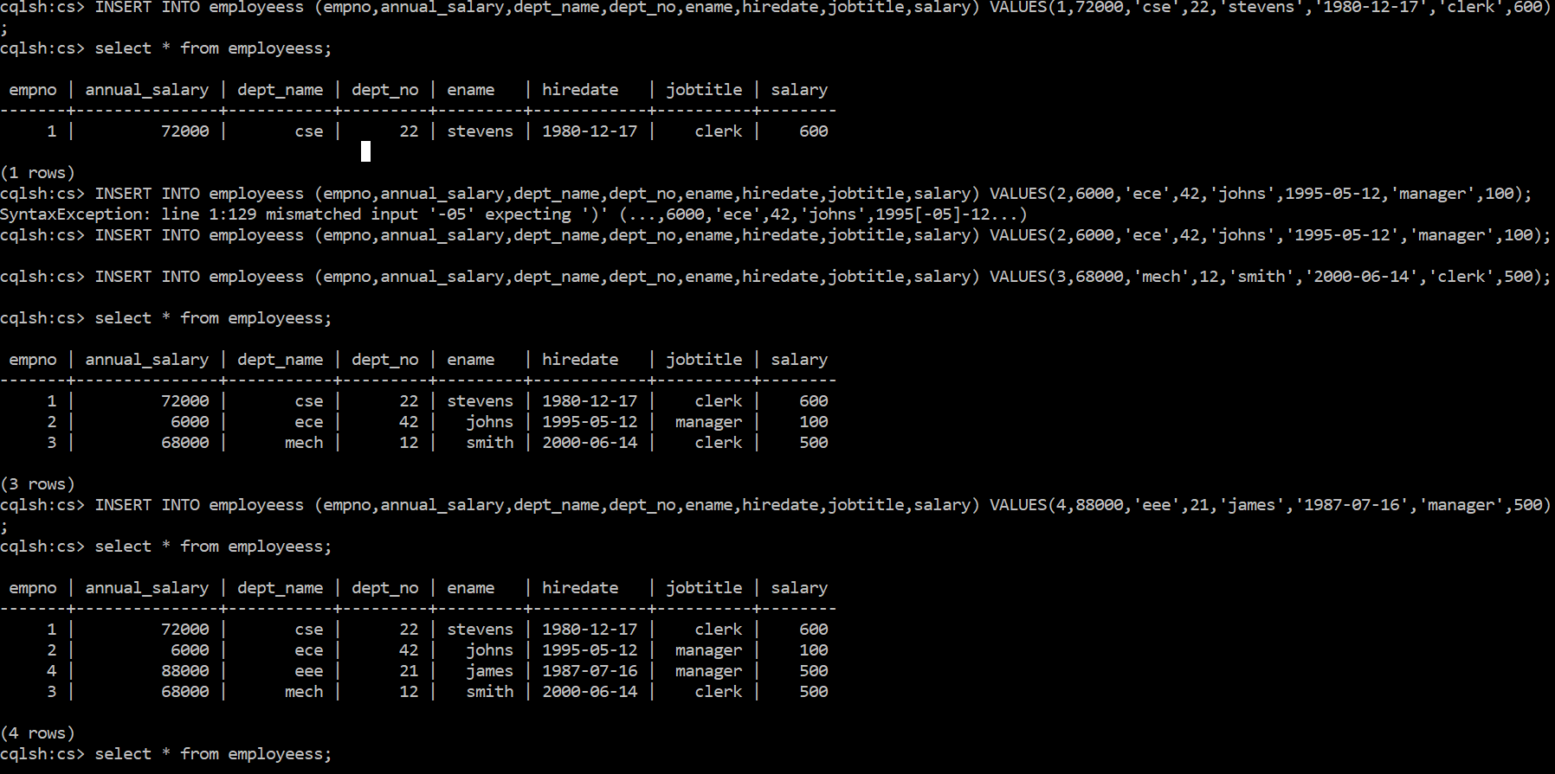

**2.** **List the name,salary of the employees who are clerks.**

Name and salary of the employees who are clerks are listed below using the following command

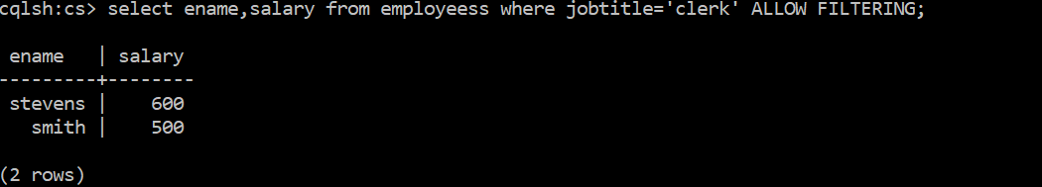

**3.** **List the name,job,salary of every employee joined on ‘december 17,1980’**

The following command in the screenshot is used to list the name, job, salary of employee who joined on December 17,1980.

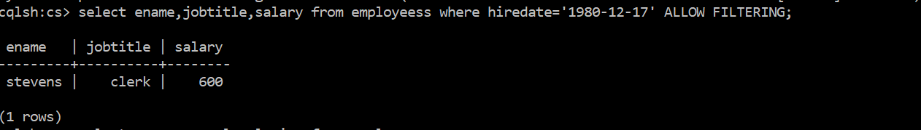

**4. List name and annual salary of all the employees**

The following command is used to list the name and annual salary of employees

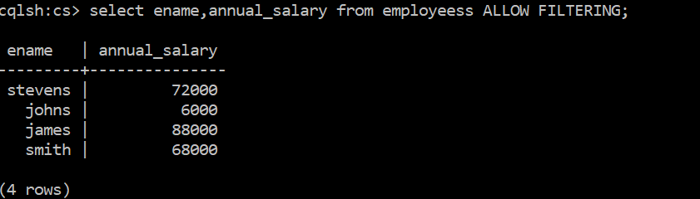

**5. List the department name & deptno for departments having deptno.>=20**

Department name and number having department number greater than 20 are listed using the following command

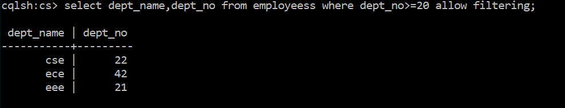

**6.** **Display employees’ names, salary and manager values of those employees whose salary is 500 from EMP table using SELECT statement.**

Employees name, salary who are managers and salary is equal to 500 are listed using the following command

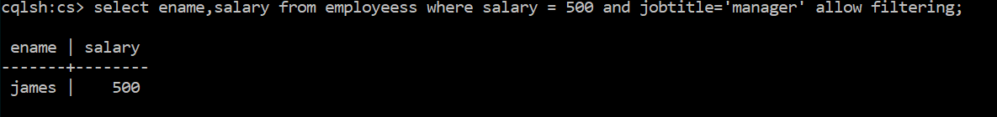

**Submitted by**

**Harish Chandra Jyoshi**

**Class ID: 8**

**Team number: 4**